SOS Consultants

Vision (Small Project)

Version 1.0

Revision History

|  |  |  |  |
| --- | --- | --- | --- |
| **Date** | **Version** | **Description** | **Author** |
| 09/20/2017 | 1.0 |  | Eric Chen |
|  |  |  |  |
|  |  |  |  |
|  |  |  |  |

Table of Contents

1. Introduction 4

1.1 References 4

2. Positioning 4

2.1 Problem Statement 4

2.2 Product Position Statement 4

3. Stakeholder and User Descriptions 5

3.1 Stakeholder Summary 5

3.2 User Summary 5

3.3 User Environment 5

3.4 Summary of Key Stakeholder or User Needs 6

3.5 Alternatives and Competition 6

4. Product Overview 7

4.1 Product Perspective 7

4.2 Assumptions and Dependencies 7

5. Product Features 7

5.1 Volunteer Form Connects to Database 7

5.2 Donor Form and Comment Section 7

5.3 Patient Referral 7

5.4 Translate Webpage 7

5.5 Links to Social Media 7

6. Other Product Requirements 8

Vision (Small Project)

# Introduction

The purpose of this document is to collect, analyze, and define high-level needs and features of the SOS Louisville Database System. It focuses on the capabilities needed by the stakeholders and the target users, and why these needs exist. The details of how the SOS Louisville fulfills these needs are detailed in the use-case and supplementary specifications.

## 1.1 References

SOS Consultants PowerPoint

# Positioning

## 2.1 Problem Statement

SOS Louisville manual records down donors and volunteers, which is very time consuming.

|  |  |
| --- | --- |
| The problem of | Not having a database |
| affects | SOS Louisville staffs |
| the impact of which is | Time consuming |
| a successful solution would be | A simple database to record all the information instead of manually recording it. |

## 2.2 Product Position Statement

By using this database, we assume, SOS Louisville will have enough time for other tasks.

|  |  |
| --- | --- |
| For | SOS Louisville |
| Who | The person usually records the data |
| The Database System | Is a software application |
| That | Provides the ability to automate the process of recording and storing donors and volunteers |
| Unlike | Currently, everything is still being manually entered |
| Our product | Provides SOS Louisville staffs with easy and simple to use database that will speed their process |

# 

# 

# Stakeholder and User Descriptions

## 3.1 Stakeholder Summary

|  |  |  |
| --- | --- | --- |
| **Name** | **Description** | **Responsibilities** |
| Board of Directors | Board of Directors. | Responsible for approving events, monitor progress, and approve funding. |
| Administrators | Manage/update website, facilitate volunteers, gather patient data and schedule events. | Responsible for the upkeep of the entire website, database, and business. |

## 

## 3.2 User Summary

|  |  |  |  |
| --- | --- | --- | --- |
| **Name** | **Description** | **Responsibilities** | **Stakeholder** |
| Volunteer | Individuals who volunteer to help during events and clinics. Fill out forms online. | Responsible for filling out the volunteer form and submitting for approval to help at events and clinics. | Administrators |
| Donor | Provide monetary donations. | Responsible for donating online. | Self |
| Doctor/Doctor’s Office | Refer patients to SOS Louisville. | Responsible for referring patients in need of care that fall under the correct circumstances to SOS Louisville. | Administrators |
| Administrator | Administrators. | Provide up-to-date information on events, types of work they perform, and program statistics. | Self |

## 3.3 User Environment

The database system will be used by the staff at SOS Louisville. As of right now, according to SOS Louisville’s website there are five staff members. Any donor, volunteer, and patient information has to be manually entered into a spreadsheet from an email. Currently donor information is stored on Google Suite and volunteer and patient information is stored locally. Improved forms will be used to automatically store donor, volunteer, and patient information to a database stored on a cloud server removing the risk of hardware failure. With a functional relational database, they will be able to run simple queries to pull specific information needed for the planning, scheduling, and coordination of organizational events.

## 3.4 Summary of Key Stakeholder or User Needs

|  |  |  |  |  |  |
| --- | --- | --- | --- | --- | --- |
| **Need** | **Priority** | **Concerns** | **Current Solution** | **Proposed Solutions** | |
| Volunteer Submission | Primary | No online form that connects to a database | Email all contents to SOS Louisville Staff | | Create a form that connects to a relational database to automatically record all data |
| Donor Submission | Primary | No way for donors to be recognized if they preferred | Routes to a Paypal payment system and gets saved in a CSV file | | Add a section that allows donors to enter in their personal information. Leave blank for anonymity |
| Patient Referral | Primary | All information gets sent as a file and manually recorded | Doctors login with a password and send information to SOS Louisville | | Doctors will still log in, but there will be a form with all possible information relating to a patient |
| Translate Webpage | Secondary | 76% of patients are Spanish speakers and cannot convert the webpage | No conversion at this time | | Add in a language conversion tool that will change the language of the webpage |
| Social Media Links | Secondary | Links are broken | Currently have social media icons available, but not all are functional | | All links will be functional and point to popular social media websites |

## 3.5 Alternatives and Competition

Instead of the proposed solution, the alternative would be to stay with the current solution, which would cause SOS Louisville to lose money.

# Product Overview

## 4.1 Product Perspective

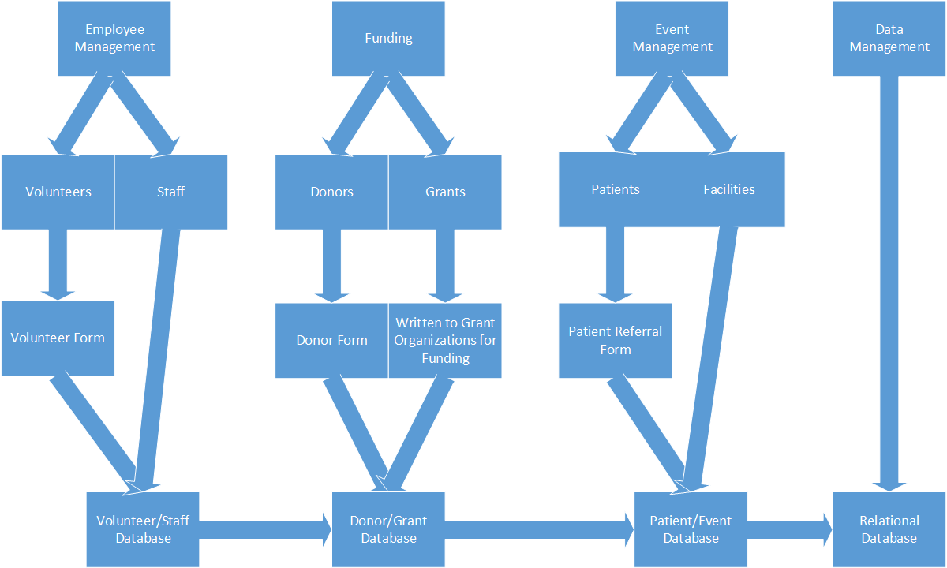

## 4.2 Assumptions and Dependencies

1. Assumed website will stay as WordPress
2. Database will be created for their business processes
3. Cloud computing for storing the database is recommended
4. Forms will directly access database

# Product Features

**5.1 Volunteer Form Connects to Database**

Volunteer forms need to be able to connect to a database

**5.2 Donor Form and Comment Section**

The donor form should have a section that allows for donor comments

**5.3 Patient Referral**

Patient referrals should be a form filled out by the doctor or doctor’s office. It will transfer to a database

**5.4 Translate Website**

Site should have a way to translate the website to Spanish

**5.5 Links to Social Media**

Should have valid social media links on their site

# Other Product Requirements

Recommended that when the system is set up the administrators back up all of their information to a secondary device. This will lessen the likelihood that information will be lost.